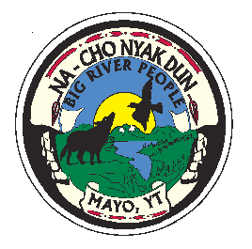
First Nation of Na-Cho Nyak Dun
C/O Enrollment Department
Box 220
Mayo, Yukon Y0B 1M0
Tel: (867) 996-2265
Fax: (867) 996-2267
E-mail: enrollment@nndfn.com
Website: www.nndfn.com

APPLYING FOR NACHO NYAK DUN CITIZENSHIP
ON BEHALF OF A MINOR CHILD

- Please complete application in full and attach a completed genealogy chart.

- Did you remember to include a photocopy of a LONG FORM birth certificate? A long form Birth Certificate shows the parent(s) names as well. You can obtain the certificate from Yukon Vital Statistics for a fee of $10.00. If the birth occurred outside of the Territory, please contact the undersigned for information on how to obtain your child’s Long Form Birth Certificate.

- Did you remember to sign the application form? NaCho Nyak Dun Enrollment Department requires that BOTH parents sign the application. If there is only one parent named on the Long Form Birth Certificate, the other partner will have to sign and swear a Statutory Declaration or attach a Custody Order.

- Anyone sixteen years of age and older can submit their own application.

Applications will not be processed without a copy of a Long Form Birth Certificate and without signatures of BOTH parents.
Thank you for your application and please remember to inform us of a name change, marriage, change of address, etc.

Enrollment Officer

