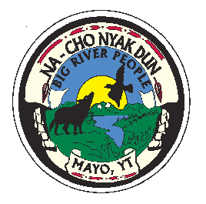
First Nation of Na-Cho Nyak Dun
Box 220 Mayo, YT, Y0B 1M0
Tel: (867) 996-2265
Fax: (867) 996-2267
E-mail: enrollment@nndfn.com
Website: www.nndfn.com
Enrollment Application for a Child
Applicant’s Name: _______________
(Last) (First) (Middle)

Present Mailing Address: ________
(Street address or box number)

________
(town or city) (territory or province) (postal code)
Female or Male (circle) Adopted: Yes or No (circle)

Birth Date: Birth Place:
(day) (month) (year) (town/city) (territory/province)
REQUIRED WITH APPLICATION IS A PHOTOCOPY OF YOUR BIRTH CERTIFICATE
THE LARGE SIZE BIRTH CERTIFICATE THAT SHOWS YOUR PARENTS NAMES
Fraction of Yukon Indian Ancestry & Nationality: (circle)
1/1, ¾, ½, ¼, 1/8, Other /

Northern Tutchone, Southern Tutchone, Gwich’in, Tlingit, Han, Tahltan, Other:

Clan: Wolf or Crow Citizenship: Canadian/ American/ Other:

Non Status or Status Number (10 Digit number):

Father’s Name: ______________
(Last) (Given Names)

Birth Date: Birth Place: _______
(day) (month) (year) (town/city) (territory/province)

Mother’s Name: _______
(Last) (Given Names)

Birth Date: Birth Place: _______
(day) (month) (year) (town/city) (territory/province)
Legal Guardian: _______
(Last) (Given Names)

Mailing Address: _______
(street address/box number) (town or city) (territory or province) (postal code)

Reason for filing on behalf of applicant: _____________________

Were you Legal resident of the Yukon on or before January 1, 1940? If Yes, where:

If No, who was Legal Resident of the Yukon on or Before 1940:

Name of Ancestor:

Relationship to you: Residence in or before 1940:

If the Applicant is a minor, the Application must have both parents consent to register with NND:

_________________
Applicant’s Mother’s Signature Date Phone Number

_________________
Applicant’s Father’s Signature Date Phone Number

