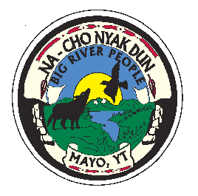
First Nation of Na-Cho Nyak Dun
C/O Enrollment Department
Box 220
Mayo, Yukon Y0B 1M0
Tel: (867) 996-2265
Fax: (867) 996-2267
E-mail: enrollment@nndfn.com
Website: www.nndfn.com

Applying for Beneficiary/Citizenship

Please fill out and sign the application and attach a completed genealogy chart.
Enclose a PHOTOCOPY ONLY of the applicant’s long form BIRTH CERTIFICATE.
Anyone over sixteen years of age can sign their own application.
If the applicant does not reside in the Yukon, kindly forward the application to them and inform us of their new address in order that we can update our file.
The Application will not be PROCESSED unless we have a photocopy of the long form Birth Certificate with the parent(s) name(s) stated thereon.
Thank you for your cooperation.

Return Application to: Enrollment Officer
First Nation of Nacho Nyak Dun
Box 220
Mayo, Yukon
Y0B 1M0

